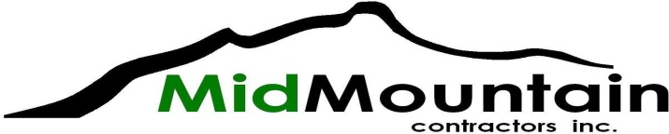

SUBCONTRACTOR/VENDOR BID REQUEST

Project: 2021 Spot Sewer Repair – Unit Price Contract

Owner: City of Seattle – Seattle Public Utilities

Bid Date: 3/3/21
Bid Time: 2:00 PM (all quotes required at least 3 hours prior to bid time)

Documents:
https://seattle.procureware.com/

Trades: Traffic Control
Trucking
Vibration and Settlement Monitoring
Sewer Bypassing
Concrete Flatwork
CCTV and Vactoring
Private Utility Locates
Landscaping
Survey
Street Sweeping
Striping
Signage

Supply: Aggregates
TESC Materials
Concrete
Pipe and Precast Structures
Shoring

Contact: Bill James (425) 202-3651; bjames@midmtn.com
Fax: 425-202-3610

MWDBE: MidMountain Contractors is an equal opportunity employer and encourage small, women, minority, veteran, disabled veteran, and disadvantaged businesses to submit proposals

Social Equity: This contract includes Apprentice Utilization Goals. These are required and all subcontractors will participate. See the project’s General Conditions Specifications for further details.

