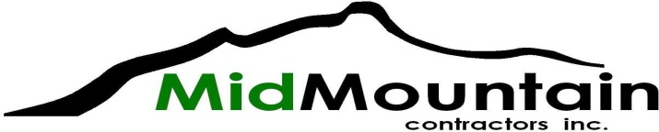

SUBCONTRACTOR/VENDOR BID REQUEST

Project: SR204 Intersection Improvements
Owner: WSDOT

Bid Date: 3/17/21
Bid Time: 11:00 AM (all quotes required at least 3 hours prior to bid time)

Documents: https://wsdot.wa.gov/biz/contaa/Contracts/default.htm

Trades: Asphalt Milling
Concrete Flatwork
Concrete Pumping
Chain Link and Cable Fencing
Directional Drilling
Electrical
Gravity Block Wall
HMA Paving
Landscaping
Precast Noise Walls
Rebar
Sawcutting and Core Drilling
Street Sweeping
Striping
Signage
Survey
Trucking
Traffic Control and UPO’s
TV Inspection
Vactor Truck Service
Wet Utilities

Supply: Aggregates
Baker Tanks and Water Treatment
Concrete
Dowel Bars
Pipe and Precast Structures
Precast Noise Wall Panels
Rebar
TESC Materials

Contact: Bill James (425) 202-3651; bjames@midmtn.com
Fax: 425-202-3610

MWVSDBE: MidMountain Contractors is an equal opportunity employer and encourage small, women, minority, veteran, disabled veteran, and disadvantaged businesses to submit proposals

Social Equity: This contract includes Apprentice Utilization Goals. These are required and all subcontractors will participate. See the project’s Special Provision Specifications for further details.

